**Agriculture Teacher Use of Large-Scale Facilities and Equipment**

Benjamin Butcher, Michigan State University

**Abstract**

Large facilities and equipment are common elements within agriculture, food and natural resources (AFNR) programs. Whether it be a greenhouse, barn, livestock trailer or tractor, every program has valuable tools that have a high impact on student learning. With 4 million dollars of state funding earmarked for improvements in capital projects and equipment within AFNR classrooms of Michigan, it is important to understand the uses, supports, and limitations of large-scale facilities or equipment in AFNR programs. This study included interviews with five AFNR teachers to seek out that information. Findings indicate facilities are used for: teaching academic standards, building student engagement, and teaching with a hands-on approach. Responses from the interviews also indicate community groups, teacher experience, administrative, industry, fellow ag teachers, and other career and technical educators as groups supporting the use of large-scale facilities and equipment. Finally, teachers identified manure handling, ventilation, time limits, out of date systems, teacher sacrifice, space, and wildlife as limits to the further use of large-scale facilities and equipment.

**Introduction**

The use of facilities such as land labs, agriculture mechanics shops, livestock facilities and greenhouses is a tradition that dates back to the inception of agricultural education. Twenter and Edwards (2017) have traced the roots of these facilities back to John Dewey, the creator of vocational education. From the inception of Dewey’s model to 1954, teachers of agricultural education found utility in facilities to guide their instruction (Twenter & Edwards, 2017). Twenter and Edwards state, “In *Providing for Facilities*, it was stated, “teachers of agriculture . . . found that teaching agricultural skills can be effective only to the extent facilities are available with which to teach the skills desired” (2017, p. 275). In their review, Twenter and Edwards (2017) provide supportive evidence that indicates how agriculture facilities have adapted, but still play a vital role in school based agricultural education today. Teachers within the State of Michigan have been using facilities such as those listed above, and equipment such as tractors, farm implements, trailers, tools and so forth to continue the advancement of agricultural education. Recently, the State of Michigan Legislature provided 4 million dollars for agriculture education programs to fund, “capital improvements, equipment procurement, resources to update curriculum for student credentialing and advancement of agriculture education across the state” (Farm News Media, 2024, para. 2). With so many programs within the state preparing to upgrade, or install agriculture facilities and equipment, it is vital to find out what supports the successful implementation of those assets.

This study looks to answer three objectives related to the use of Large-Scale Facilities and Equipment (LSFE). A working definition of a LSFE has been established by this research team as, a highly valuable (monetarily) facility including but not limited to a greenhouse, flower shop, land lab, animal facility, or equipment including but not limited to a livestock trailer, tractor, or power tools. This study aims to:

1. Describe the use of LSFE within agriculture, food and natural resources (AFNR) programs.
2. Identify the barriers to additional use of LSFE’s,
3. Identify the support factors of using and implementing LSFE within a teacher’s program.

**Literature Review**

Several studies have cited large-scale agriculture education facilities and equipment in the past, each analyzing specific functions of the assets. One study by Howell et al. (2017) surveyed 72 teachers from the state asking which types of infrastructure were present in their programs. Results showed that 89% of those surveyed had greenhouses in their programs, while 75% had access to natural resources, and 54% had livestock housing incorporated in their AFNR programs (Howell et al., 2017). Given the sample size, this study provides a clear picture about Michigan AFNR programs and facilities. As such, it is important to realize the scope of facilities available to Michigan teachers, but what are the limits and supports of such assets?

Considering the limits and supports of an agricultural facility, one study by Lambert et al. (2018, p. 202) from Oregon surveyed 64 agriculture teachers about the support for their school farms. The data indicated the average teacher found 67.53% of the community was supportive of their school farm. What's even more interesting is that none of the teachers surveyed in the study indicated 0% support, and none indicated 100% support of their school farm from their community (Lambert et al., 2018, p. 202). While support from the local community is clearly vital to the operation of a large-scale asset, is it the only support that is needed? The same research study found that the condition of the school farm, facilities, finances, teachers’ ability to oversee, and the teacher’s ability to engage students were the top drawbacks from using the school farm (Lambert et al., 2018, p. 208). One factor that was not studied in the above research was the role of administration in building/using large-scale assets such as a school farm. The study also used a survey with set responses to gather their data whereas a more open interview style would allow other factors not accounted for by researchers to be brought forth by the survey respondents.

**Methods**

For this study, the lead researcher interviewed five AFNR teachers with varying backgrounds from locations throughout the State of Michigan. Careful consideration was taken to ensure teachers from various situations were represented. Those situations included teachers who taught at career centers, comprehensive public high schools, first give years of teaching, longer than five years of teaching, traditionally certified teachers, and those who are annually authorized. In order that representation from each group could be obtained, the Supervisor of Agriculture Education in the State of Michigan was consulted when determining a representative list of possible situations for this research.

Teachers who agreed to participate in the study participated in an interview with the researcher via Zoom, or face to face. Audio recordings of each interview were collected, and corresponding data were sent out for transcription. Participants were asked a series of questions related to LSFE. The first question asked, “What are the five most financially valuable large-scale facilities/pieces of equipment within your program?” A follow up question included, “To what extent do you use these five large-scale facilities and pieces of equipment within your agriscience program?” which investigated the use of these facilities within the AFNR program. In order to determine the utility of the LSFE within the program, the researchers asked if the asset was used to: 1) meet academic standards, 2) promote student learning, 3) fund the program, or 4) increase student engagement in extracurricular programs. The researcher then asked the interviewees what limited them from using these five assets more, and what supported the use of these five assets in their program. Once interviews were completed and transcribed, analysis of transcribed data was completed using the methods set forth by Flick (2008), and Strauss and Corbin (1990). This process identified the relevant information from the interviews conducted. After the information was sorted, the constant comparative method outlined by Flick (2008) and Strauss and Corbin (1990) was used to create and define codes summarizing the data. Thematic coding (Flick 2008; Strauss & Corbin 1990), was then used to devise three common themes from the codes obtained in the previous step. Finally, a model was developed to explain the relationship between the three themes and the corresponding codes.

**Results**

The data resulting from the interviews were sorted into three overarching themes: the necessary support features of LSFE’s, the utilization of LSFE’s, and the educational utility of LSFE’s. As we look at the interactions of each of these three themes, we can organize them in a model that resembles a tiered cake (Figure 1).

**Figure 1**

*Cake Model of Large-Scale Facilities and Equipment Within Agriculture Education Settings*

*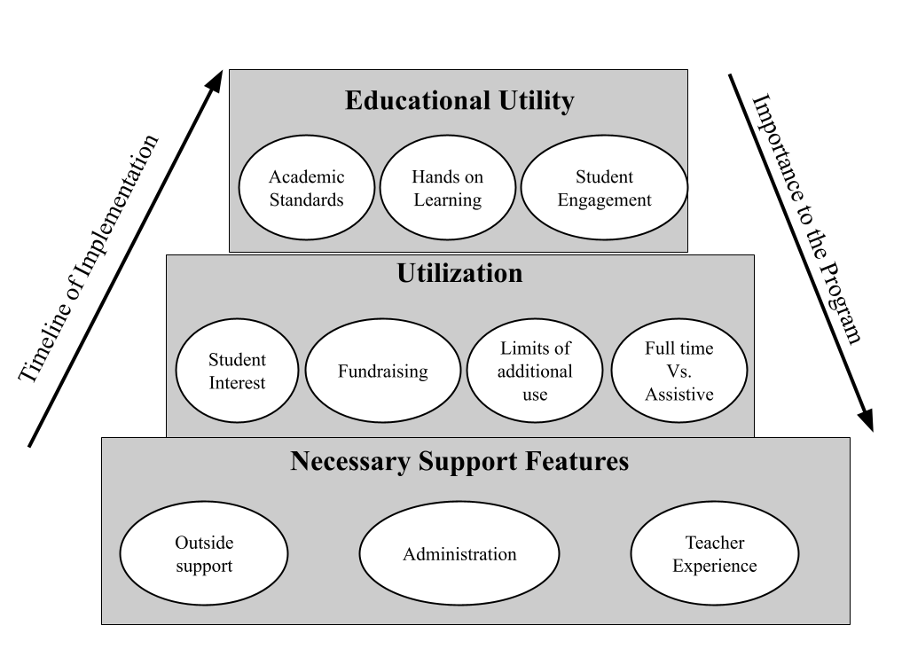Note.* This figure explains the order of importance of the overarching themes during the implementation of the project, and the evaluation of the project's value.

Working from the bottom of the model (Figure 1) to the top, the necessary support features build the solid base of the cake model. Above that solid support is the next tier, which is utilization. Out of that utilization of the asset comes forth the educational utility - how students are truly impacted by the facility or equipment. On the left side of the figure, the arrow moves from the bottom tier to the top tier. This is to show that when building or implementing a new large-scale facility or piece of equipment, the project typically starts at the base by acquiring support, building the asset, using it, and deriving the educational utility from that asset. When evaluating a program or the benefits of a LSFE, the model works in reverse. High value is placed in the educational utility provided by the asset. However, no educational utility can be assigned to an asset if it is not utilized in agricultural education, and without the necessary support features, the asset could not be utilized.

Within the theme of necessary support features, is the thematic code of *outside support*. Outside support in this study was defined as a person or organization that helps advocate for the development and use of LSFE. Through the interview process, several support groups were identified including fellow AFNR teachers, Alumni groups, community, industry, fellow career and technical education teachers, and paraprofessionals. When talking about the support that Alumni offers a program, one respondent noted,

“The Alumni also run the sugar shack. If they didn't do that, you wouldn't be able to focus on anything in the classroom because you would be tied to that process.”

The Alumni groups are important, but one group that several interviewees mentioned was fellow AFNR teachers. Two programs actually have a retired teacher that brings in bred ewes for their students to experience the lamb birthing process, all while providing whatever support is needed to the teacher of the program. On the community and industry side, several programs noted the amount of money and labor that is donated by members of the community and the agricultural industry. One respondent said,

“We have 20 community partners who donate time, materials, and money.”

The program that was supported by these 20 community partners had several donated items such as farrowing crates and greenhouse materials in addition to the time spent by volunteers helping to manage the large-scale facilities within the program.

The next thematic code in the necessary support theme is *administration*. This is defined as the role school administration plays in the acquisition and implementation of LSFE. All the teachers interviewed started by listing their administration as a support, only to tell about a time when they had to really work with administration in order to get something built or funded. Most of my interviewees have spent a considerable amount of time explaining things about the AFNR program to their administrators. One teacher summed it up very well saying,

“Do they set out to be a pain and a problem all the time, NO. But through ignorance, they sure are a pain.”

With that type of negative sentiment around working with administration, how do teachers navigate the situation? One respondent put it this way,

“It just takes time, I came in here thinking, I know all the school board members, and I know all the teachers, I know the community, I grew up in this area, I am going to come in here, and I am going to do this. And it takes time to switch things, and get new things, you have to prove to the community the need before things work out.”

*Teacher experience* makes up the final thematic code of the necessary support theme. Teacher experience is defined as the background knowledge the teacher brings into the program, and the willingness of the teacher to learn new things in order to implement a LSFE in their program. Researchers found that the type of LSFE a program will utilize is one that is tied to the interests and experiences of the teacher in that program. One respondent illustrates this by saying,

“[My] personal knowledge and interest, support the facilities in the way they are used. I didn't grow up around steers or feeders - don't have them in the program.”

This particular individual was very comfortable with sheep, and they did have sheep in their school livestock facility. On the other side of this coin, some teachers are willing to learn with the students and implement facilities and equipment that they have little experience with. One teacher puts it this way,

“I was exposed to these experiences before I came to [the town they teach in], but was not an expert. Student interest drove instruction, and whatever that was, I became an expert in. For example, the syrup project. Am I a forestry expert? No. Did I become an expert because of the resource? Yes, and the students enjoyed it. I just try to become an expert based on opportunity and interest.”

Within the utilization theme, the first thematic code is *student interest*. This describes how student interest plays a role in the utilization of LSFE. Teachers evaluate their program year after year, making changes to their curriculum and how they use the LSFE, for example, one teacher reported,

“It has been hard to get enough workers committed for the sugar shack, and it was essential for our program. So, seeing an opportunity for a plant sale, not having any idea how great it would turn out, I said it's something a little bit different, and easier to manage with class time labor. The kids loved the plant sale and the flowers, so it was an easy win.”

That is a great example of how students can change the frequency of one asset over another. In addition, students also have quite a way of getting folks to build or establish new facilities. One teacher explained by saying,

“Kids love the chickens - this is what allowed administration to see the need for a new barn.”

The next thematic code within the utilization theme is *fundraising*. This shows how LSFE’s are used to raise money for the program that they support. Every respondent in the study mentioned how important their LSFE was to funding their program. One teacher said,

“Added cost funds [state funding for AFNR programs] have been decreasing, it has been very important to subsidize our program's needs and build additional means to fund our program.”

80% of the respondents in this study had a greenhouse in their program, and each of them used that greenhouse to sell plants (house type or spring annual). When researchers asked a teacher who is very comfortable with animal science and indicated lower comfort levels with plants, why they use their greenhouse they said,

“[The] plant sales are well established and raise money so we can’t get rid of it.”

The *limits of further* use code also falls in the utilization theme. This thematic code describes and attempts to seek out what factors limit the additional use of an asset that is already deployed by the program. When respondents were asked what holds them back from using their LSFE more often, some responses included manure handling, ventilation, time limits, out of date systems, space, teacher sacrifice, and wildlife. For all the programs that have already incorporated livestock, every teacher mentioned lack of ventilation as a problem. Most of these buildings were built for different purposes (storage, agricultural mechanics) so in the conversion to animal raising, they lack the proper ventilation systems for an animal system. An additional limitation that came up was time limits especially in using LSFE that are used in the same season. One teacher explained this by saying,

“If we were to go further, we would need more teachers. [The] sugar shack and greenhouse work against each other because they are at the same time of year, [and I am] limited by manpower from the time management aspect of it.”

Teacher sacrifice came up in several of the conversations about LSFE. Respondents indicated that running LSFE requires them to work within those assets outside of school-contracted time. That could mean doing chores on the weekends, watering plants before and after school, and chasing animals when they get out of their pens. This was seen as a drawback on teacher down time and time spent with their families. The last response was wildlife. This limitation was used to describe the effect of wildlife species such as deer on assets that grow crops outside like a land laboratory.

The last thematic code in utilization is *full time vs. assistive*. This describes what LSFE are used almost daily, and which ones are used only when needed. All of the respondents who had livestock facilities, or greenhouses classified those assets as used every day. Other assets such as tractors, livestock trailers, power tools, and enclosed trailers are classified as “used when needed.” If equipment is only used a few times, does that make it less valuable? One teacher puts it like this,

“[The] tractor is used in the greenhouse, and livestock facility, but without the tractor, the maple syrup would not be possible.”

*Academic standards* was a thematic code that is categorized within the educational utility theme. This details all the ways AFNR standards are being taught through LSFE’s. Teachers collectively identified their current assets teaching animal, plant, business, career readiness, safety, and environmental standards. One teacher was talking about what they taught using their greenhouse stating,

“All things botany - plant parts, functions, soil media, nutrition, ag business, marketing opportunities through the plant process.”

When we finished talking about academic standards, one of the respondents said,

“Would you be able to teach Ag without those facilities? I would say I think it would be extremely difficult.”

*Hands-on learning* is another thematic code that finds itself in the educational utility theme. This code includes how hands-on learning is used and encouraged through the use of LSFE. Every single respondent noted that their LSFE are assets for hands-on learning to take place. One teacher talked about how these facilities teach lessons without planning. They explain by saying,

“Because they’re [the facilities and projects they sponsor] dynamic living creatures, problems arise, and we need to go back and dive deep to learn or figure something out. So yes, hands-on learning, but also a little bit of phenomenon based learning to.”

It is uncontested that these facilities allow students a place to practice what they learned in class and use their hands as part of the process. A teacher puts it all into perspective by explaining a simple phenomenon that happened in their LSFE resulting in a hands-on learning experience,

“One example would be this water. It is critical. We don’t water the plants, they don’t grow. In fact, they’re dying. This is terrible! And yet water has to move against the force of gravity, to move up through those plants. How in the world does that happen? Well, now we’ve got a conversation now we got to start digging deep. Now we start learning about properties of water, moving plants, the tissues that support it. So, it actually supports critical thinking.”

Finally, *student engagement* is a thematic code that falls in the educational utility theme and considers how facilities encourage students to take part in FFA or Supervised Agricultural Experiences (SAE’s). The respondents collectively identified increased participation in co-op, placement, school-based, and agriscience SAE’s in addition to increased enrollment in their agriculture class as a result of having and using LSFE’s.

“Kids really love those hands-on opportunities, and I think that without those opportunities, these kinds of facilities offer, I don’t think there's many people that come and sign up for a class. Your academic rigor would have to be reduced without these facilities, because students wouldn’t be enjoying it, so they wouldn’t learn as much”

Another respondent described the effect of LSFE on recruitment like this,

“Students that come in here, say they are in animal science class or 8th grade and are not really familiar with animals. They see what you can do. You can take them to fair, you can help in the barn, whatever, on weekends, and they get more involved that way. I‘ve noticed those students who start off not very involved. After they experience something like that, they start coming to FFA meetings.”

**Conclusions**

Through this study, one thing that really stood out was the emphasis interviewees placed on the ability of these facilities to recruit students. While recruitment may not be a reason that helps a teacher support the adoption of a new asset, it is a tool for teachers to consider when they are thinking about recruitment of prospective students within their programs. How can instructors and student leadership teams use the facilities and equipment they have to help build membership or enrollment? One tangential recruitment tool would be to utilize new assets for facility tours of prospective students, or host school events in their facilities or use their equipment to bring awareness to the AFNR program.

One implication of this research was the effect of personal experience on the asset in question. As highlighted above, one quote from a respondent indicated how important it was that he became a student and learned how to operate the facility or equipment along with the students. It was this willingness to take on new LSFE’s, and learn how to use them, that he himself became a great resource for other teachers looking to implement similar LSFE’s to turn to for help and advice. When talking with early career respondents, or those who were annually authorized, there wasn’t the drive in those teachers to try something new, or the willingness to incorporate a new facility or equipment without themselves being an “expert” in that area first. For example, several of the teachers that were interviewed had “land labs,” or areas of the school campus once utilized for agricultural practices such as the production of field crops for demonstration purposes. Many years ago, it was common for AFNR programs in the state to maintain those types of facilities. The respondents interviewed who had existing land labs, noted that they barely used those assets. Several of the respondents indicated not feeling comfortable operating land labs, while others had little interest in plants at all, and shifted their program to be more animal focused. I understand that some of these older assets are not as exciting to younger teachers, and that maybe student interest doesn’t allow them to be utilized as well, but why are teachers afraid of not being an expert? That is a good place to start further research.

As part of this research, we have now identified the supports and the limitations of LSFE’s. This research can be built upon to determine how we can better prepare new teachers, both traditionally certified and annually authorized for taking over the management of existing LSFE’s that they will inherit. The research team would recommend further exploration of why teachers with many years of experience were the individuals reaching out to and utilizing other ag teachers in state for ideas and support as they implemented or used LSFE in their programs. The early career respondents in this current study rarely mentioned using their peers as resources and did not indicate reaching out within the profession for help. It has also been determined through this research that the support of school administration is vital to the success of LSFE. It is also noted that teachers are experiencing great frustration as they work with their administration to get to a point of support from the school's administration. What can be done to support current and upcoming teachers as they work with their school administration? That is a question that warrants further investigation for the mental health and well-being of our AFNR instructors.

Current AFNR teachers can use the LSFE model to determine appropriate interactions with specific assets in their programs. The model (Figure 1) developed from this research has a two-pronged application for AFNR programs. The left side of the model highlights the “timeline of implementation,” otherwise known as the steps in the process of obtaining a new asset. It is critically important the instructors have support from the community and administration before beginning the acquisition process. After the proposed asset is obtained, the second tier of the model comes into play and the program will begin to utilize the asset through classroom instruction, fundraising, and hands-on learning. After using the asset, educators will notice the educational utility of the asset including student learning, covering academic standards, and building a larger program through recruitment. On the right side of the model (Figure 1), we see “importance to the program.” Educational utility is first and foremost because as a program is evaluated, the positive impact to student learning as a result of the asset is top priority. The middle tier brings additional value to the program by providing a way to raise funds or provide hands-on experiences to the program. In the bottom tier, value is assigned to the asset as those relationships fostered with the community are utilized to place students in work based learning experiences, and provide a connection between the AFNR program and the local agricultural industry. It is our hope that this tool along with the discussions of the limitations and support of LSFE’s will assist educators in evaluating the use of current LSFE’s in addition to the acquisition of new LSFE’s within their AFNR programs.

References

Farm News Media. (2024, March 22). $4M awarded to mi ag education programs, FFA chapters. *Michigan Farm News*.

Flick, U. (2009). *An introduction to qualitative research* (4th ed.). Sage Publications.

Howell, K., Everett, M. W., Forbush, M., McKim, A. J., & Raven, M. R. (2017). Descriptive  
 survey of agriculture, food, and natural resources education programs within the state of  
 Michigan. *Michigan State University Undergraduate Research and Arts Forum.*

Lambert, M. D., Stewart, J., & Claflin, K. (2018). Understanding characteristics, uses,  
 perceptions, and barriers related to school farms in Oregon. *Journal of Agricultural*  
 *Education*, *59*(2), 197–214. https://doi.org/10.5032/jae.2018.02197

Strauss, A., & Corbin, J. M. (1990). *Basics of qualitative research: Grounded theory procedures  
 and techniques*. SAGE Publications.

Twenter, J. P., & Edwards, M. C. (2017). Facilities in school-based agricultural education  
 (SBAE): A historical inquiry. *Journal of Agricultural Education*, *58*(3), 275–292.  
 https://doi.org/10.5032/jae.2017.03275